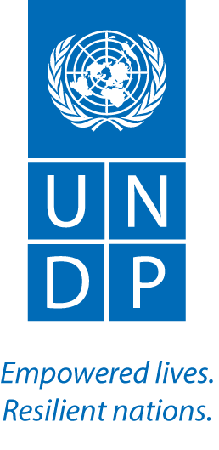

United Nations Development Programme
Country: _Guinea
Project Document

Project Title | Emergency support to national response to Ebola
UNDAF Outcome(s): | UNDAF Outcome #1 Until 2017, democratic institutions, judiciary and security systems are functioning on the basis of transparent dialogue and consultation, in accordance with national and international norms, and ensure effective protection of individual and collective freedoms.  UNDAF Outcome #2 Until 2017 the public and private sectors, the decentralized institutions and the local communities adopt new techniques and behaviours leading to a sustainable environment and an improved prevention and risk management of natural disasters in a context of adaptation to climate change
Expected CP Outcome(s):  (Those linked to the project and extracted from the CP) | Outcome 2.3. from the CP : By 2017, crises and conflicts situations are anticipated and better managed, emerging tensions are defused and existing conflicts are solved through dialogue.
Expected Output(s):  (Those that will result from the project) | Output 1: Coordination and delivery of essential health and other basic services strengthened in Guinea  Output 2: Enhanced community engagement, with a particular focus on vulnerable and at-risk groups such as women and youth
Executing Entity: | UNDP
Implementing Agencies | UNDP

Total resources required USD 2,886,000_
Total allocated resources: USD 2,886,000_
- Regular _________
- Other:
  - Donor Japan__
  - _________
  - Government _________
Unfunded budget: _________

In-kind Contributions 200,000

Programme Period: Years 2015-2016 ______________

Key Result Area (Strategic Plan)

Outcome 6: Early Recovery and a Rapid Return to Sustainable Development Pathways Achieved

Atlas Award ID: ______________

Start date: March 2015
End Date March 2016

PAC Meeting Date ______________

Management Arrangements DIM________

Brief Description
The project will support the National response to Ebola through two main components:
- Strengthen coordination and delivery of essential health and other basic services
UNDP will build on its health and governance work in Guinea to support coordination mechanisms to monitor and respond to Ebola under Component 1. This will be done in close collaboration with government line ministries, civil society, the international community and national and regional Ebola crisis coordination centres. This component consists of the following key interventions aimed at stopping and mitigating the impact of Ebola:
      - Strengthening the coordination of the immediate response to Ebola epidemic
      - Provision of health sector equipment, supplies and infrastructures, particularly safe and environmentally friendly disposal of health care waste contaminated with EBV
      - Strengthening of security sector response
- Improving the engagement with communities, with a particular focus on vulnerable and at-risk groups such as women and youth
This component will build on UNDP’s expertise in social mobilization, to deliver on community engagement strategies that aim to ensure at-risk populations, particularly women and youth, in affected areas are reached with well-crafted Ebola preventive messages. Of crucial importance, 200 Community Watch Committees will be established and supported during 6 months

Agreed by (Government)

Agreed by (UNDP):

Situation Analysis
Beyond the death and suffering caused by the Ebola virus disease (EVD) and the collapse of health care systems in Guinea, the Ebola crisis will have lasting development consequences in the region. The epidemic burst as Guinea is still recovering from years of instability.
Health systems were not strong prior to Ebola, and now the burden placed on them by the epidemic means resources and staffs are grossly insufficient to meet other health needs such as maternal health, malaria and tuberculosis. There is concern that child and maternal mortality may increase as a direct result of less resources and staff available for these needs. The loss of educated and experienced health care workers who were central to efforts to strengthen health care systems further exacerbates the problem. Few resources and funding have been made available to strengthen health care systems, both from within the affected countries and from international aid.

The national, regional, and international response to the disease has been gaining momentum, with an immediate focus on treatment and stopping the transmission of the virus. Health ministers from 11 countries in the West African region convened from 2-3 July 2014, to define a common approach to the Ebola outbreak, developing the Accra Response Strategy.
The Accra Response Strategy underlines the national and UN response plans for Guinea, Liberia and Sierra Leone and WHO’s Ebola Response Roadmap. Participants in the meeting agreed on three pillars for action: (1) immediate outbreak response interventions; (2) enhancing coordination and collaboration; and (3) scaling-up of human and financial resource mobilization. The pillars cover four thematic areas: (i) coordination, finance, and logistics; (ii) epidemiology and laboratory; (iii) case management, infection prevention and control and psychosocial support; and (iv) social mobilization and public information. The Accra meeting resulted in the establishment of a WHO sub-regional coordination centre, in Conakry, as a hub for Ebola information and coordination in the region.

In September, the UN Security Council declared the outbreak in West Africa a "threat to international peace and security" and unanimously adopted a resolution urging Member States to provide more resources to fight the spread of EVD. To date, a number of organizations and countries have pledged contributions. The Economic Community of West African States (ECOWAS) has pledged resources and the World Food Programme (WFP) announced plans to mobilize food assistance; the World Bank has committed USD 400 million to the three nations and the International Monetary Fund (IMF) is providing 130 million in emergency financing, while Japan has generously also contributed over $100 million for Ebola response.

Efforts thus far have been able to “bend the curve” of new infections, but more needs to be done. Indeed, the weak health system and socio-cultural practices coupled with frequent movements of people are still hindering efforts to fight the outbreak, including in densely populated urban cities such as Conakry, Guéckédou, Nzérékoré, Macenta and Lola (Nzerekore region), Forecariah, Dubréka, and Coyah (Kindia region), Siguiri (Kankan region).

There continues to be an urgent need to step up UN and international response. The total reported cases in Guinea as of 31st December 2014 amounted to 2,435 cases and 1463 deaths.

At the recent annual meeting of the IMF and the WB, the Secretary General called for a 20-fold surge in international aid to fight the outbreak. Working closely with the UN Mission for Ebola Emergency Response (UNMEER) and other UN agencies on the ground, UNDP has deployed additional staff in Guinea to boost the organization’s response. It is within this response that UNDP has developed this project document, which aims to provide a firm contribution in key areas of the Ebola response.

Strategy
The overall goal of this project is to strengthen Governments’ capacities to coordinate the national response to Ebola, strengthen the UNDP country office in its coordination of Ebola response, enhance community engagement and manage the biological waste generated by the Ebola epidemic in the health care facilities. In line with the United Nations’ 5 Strategic Objectives and 13 Mission Critical Actions to combat Ebola, and in close partnership with UNMEER and the United Nations Development System, UNDP support efforts to stop the epidemic and ensure that the country, communities and individuals can recover quickly and sustainably.

The strategy will be articulated around two components:

COMPONENT 1: STRENGTHEN COORDINATION AND DELIVERY OF ESSENTIAL HEALTH AND OTHER BASIC SERVICES

UNDP will build on its health and governance work in Guinea to support coordination mechanisms to monitor and respond to Ebola under Component 1. This will be done in close collaboration with government line ministries, civil society, the international community and national and regional Ebola crisis coordination centers. Component 1 consists of the following key interventions aimed at stopping and mitigating the impact of Ebola:

- Provision of health sector equipment, supplies and infrastructure
New Waste Management Technology
In order to ensure that highly contagious, Ebola-related medical waste is appropriately disposed of, UNDP will deploy waste management units, or ‘autoclaves’, in the three countries. These environmentally friendly and relatively cost effective waste management facilities will be provided based on an innovative technology developed by the Global Environment Fund, WHO and South African research institutions.

UNDP will also focus on the provision of health sector equipment, supplies and infrastructure in affected areas, to allow the safe and environmentally friendly disposal of health care waste contaminated with EBV. In Guinea, UNDP is already supporting emergency procurement of TB supplies and mainstreaming health and hygiene in its programmes in rural areas.

The environmentally friendly disposal will be installed in 30 health structures throughout the country. This new equipment follows WHO guidelines and the Ministry of Health protocols for biologic and waste management.

- Strengthening the coordination of security sector responses: Lastly, UNDP will seek to provide capacity building support to national security sectors to better contain the spread of the disease through border screenings and other related services (e.g. manning road blocks, new prisoner observation units/training to prison officials, quarantine protocols, community policing).

COMPONENT 2: IMPROVE ENGAGEMENT WITH COMMUNITIES, WITH A PARTICULAR FOCUS ON VULNERABLE AND AT-RISK GROUPS SUCH AS WOMEN AND YOUTH

Bringing social mobilization closer to the population and getting community members directly involved in neighbourhood sensitization and watch for behaviour changes, early alert and referral of suspected Ebola cases and contacts, has been identified as one of the most critical factors in fighting the spread of the epidemic.

Component 2 will build on UNDP’s expertise in social mobilization to deliver on community engagement strategies that aim to ensure at-risk populations, particularly women and youth, in affected areas are reached with well-crafted Ebola preventive messages.
Community engagement is essential to reducing transmission and defeating Ebola and goes beyond providing information and messages to the community; it is also about listening to communities and incorporating their input and perspectives into operational approaches. Effective community engagement includes collaboration, social behavioural change and social mobilization. Perhaps above all, community engagement is about forging trust and fruitful partnerships to encourage and assist communities to take action on the most important issues facing them (e.g. food security or education of children).

Effective community engagement will be critical to the success of the Ebola response as it will: create ownership of the response at various local levels; reduce risks for families and communities; promote safe and dignified burials; encourage communities to see community care centers (CCCs) as acceptable and appropriate in the continuum of care; generate demand for services in a timely manner; and enable a looped flow of information.

Community engagement will need to leverage various channels to reach relevant populations. Traditional leaders, local healers and networks of women and youth will be important allies.
UNICEF leads this area of work within the UN system. Joint programming and joint work planning has been initiated between UNDP and UNICEF in this area. Joint project documents have been submitted to Multi Partner Trust Fund (MPTF) and funded in this area of work. However more needs to be done to establish community watch committees in all affected area.

Under this component, UNDP will therefore, in partnership with UNICEF and the national coordination cell, support the scaling-up of social mobilization interventions to outer districts and border zones in close. Public awareness will be intensified through local radio and television broadcasts, door-to-door campaigns, cellphone messaging and overall support to local media in carrying out consistent and constructive EVD responses. Training of community mobilizers, women and youth leaders, teachers and religious leaders in outreach techniques and messaging around the care and prevention of Ebola, and promoting responsible behaviors to dispel rumors and reduce stigma, will be conducted.

UNDP will enhance community engagement, with a particular focus on vulnerable and at-risk groups. The Country Office (CO) will focus on prevention, sensitization and communication to change aversion behavior in response to the outbreak. Strategic interventions will include: i) targeting communities in the Guinée forèstière districts, focusing on community engagement and sensitization related to treatment, prevention, stigma, tracing and improvement of health-related infrastructure; ii) in Upper Guinée, rehabilitating basic health infrastructure and targeting local development organizations with appropriate Ebola-related messages; iii) contributing to the overall improvement of EVD security through the ongoing UNDP Community Police project (e.g. by enlarging the scope of peace and security personnel at the borders); and iv) training a network of women and youth leaders, opinion leaders, Ebola survivors, community-based organizations (CBOs) and NGOs in Ebola treatment, prevention, stigma, tracing and improvement of basic hygiene through ongoing UN Volunteer activities).

Finally, this component will have a strong focus on women (reflecting upon their role as caregiver to the sick and their involvement in burial of the dead) and youth. Interventions will be aimed at equipping women and youth with specific and practical information that relates to their true-to-life situations (e.g. providing information that enables women to better take care of sick family members and themselves). Other key strategic interventions will include supporting the design, printing and distribution of Ebola prevention materials targeting women and young people, which will be translated into local languages.

This project will strengthen existing partnerships with national NGOs and Civil Society Organizations (CERADE, CENAFOD, CNOCS) working in the communities to set up the CWCs and the scaling up of social mobilization.
Through this project UNDP and its partners will set up 200 Community Watch Committees (CWCs).
UNDP will enhance community engagement, with a particular focus on vulnerable and at-risk groups such as women and youth, targeting communities: i) in the Forest Guinée districts; ii) in Upper Guinée and iii) training a network of youth leaders, opinion leaders, Ebola survivors, community-based organizations (CBOs) and non-governmental (NGOs) in Ebola treatment.
The main objective is to improve community participation, buy-in and ownership, de-stigmatization targeting Ebola Virus Disease (EVD) patients and their relatives, seeking of care for Ebola patients and contact-tracing of exposed family members and other members of the community.
The Community Watch Committees (CWC) includes traditional and religious leaders, representatives of women and the youth, representatives of traditional brotherhoods (traditional hunters and healers) and other opinion leaders and groups of in the village.
The CWCs will utilize image boxes as education and sensitization tools at the village levels, improving village knowledge on Ebola prevention. UNDP and the national coordination cell personnel will supervise these CWCs in order to ensure that they are following national guidelines.

Results and Resources Framework
Intended Outcome as stated in the Country Programme Results and Resource Framework:
Outcome 2.3. from the CP : By 2017, crises and conflicts situations are anticipated and better managed, emerging tensions are defused and existing conflicts are solved through dialogue
Outcome indicators as stated in the Country Programme Results and Resources Framework, including baseline and targets:
Baseline : (0) (2011) Target : (1)
Applicable Key Result Area (from Strategic Plan):
Outcome 6: Early Recovery and a Rapid Return to Sustainable Development Pathways Achieved
Partnership Strategy
Project title and ID (ATLAS Award ID): Emergency support to national response to Ebola
INTENDED OUTPUTS | OUTPUT TARGETS FOR (YEARS) | INDICATIVE ACTIVITIES | RESPONSIBLE PARTIES | INPUTS
Output 1: Coordination and delivery of essential health and other basic services strengthened in Guinea  Indicators:  Indicator 1.1. (a) : Number of Health facilities equipped with safe and environmentally friendly disposal of health care waste contaminated with EBV  Indicator 1.1 (b): Number of national technical staff trained to operate and maintain adequate disposal of health care waste  Baseline: Health facilities are not equipped with adequate waste management systems; local staff is not qualified to operate the needed devices  Indicator 1.2. (a) Improved qualification of the Security sector to address EVD  Indicator 1.2. (b) Better containment of the EVD through improved border screening and other related services (e.g. manning road blocks, quarantine protocols, community policing)  Baseline: Security staff poorly equipped and poorly qualifies to foster security in Ebola affected area  Indicator 1.3. UNDP Country Office has a project management unit and an enhanced M&E capacity  Baseline: No project management unit in place; Overstretched M&E capacity in UNDP office | Targets  - National coordination cell is reinforced and lead the Ebola response  - 30 health structures in 30 sub-prefectures are equipped with waste management systems  - 100 technicians are trained and able to manage waste disposals adequately  - Staffs in 30 hospitals are equipped with protective gears and follow security protocols  - 30 maintenance plans updated and 60 employees trained to maintain Health care facilities | Activity result 1.1.: Capacity of health facilities to adequate manage hazardous waste strengthened  Actions:  1.1.1 Provide health facilities with healthcare waste treatment systems.  (30 units x 31,286 $)  1.1.2 Train 100 health staff on waste disposal management  1.1.3. Equip 30 hospitals with protective gears  1.1.4. Update 30 maintenance plans and train 66 health staff employees in maintenance of health care centres  Activity result 1.2. Enhanced capacity of national authorities to effectively respond to EVD  Actions  1.2.1. Training of police and gendarmerie to master quarantine protocols and effectively foster security in Ebola affected area  1.2.2. Equipment of police and gendarmerie to effectively ensure the safety of the medical response in Ebola affected area  (4 pick-up x 32,000$; 9 motorbikes x 2,000$; Communication equipment, 10,000$)  Activity result 1.3. Enhanced capacity national authorities and UNDP office to effectively respond to EVD  Actions:  1.3.1. Identify and hire a project manager (P4 x 3 months)  1.3.2. Programme manager support unit P3 x 3 months  1.3.3. M&E P3 x 3months  1.3.3. Identify and hire one national service contract (1 year) expert for community engagement component  1.3.4.Identify and hire one national service contract manager for waste management disposal component  1.3.5. Identify and hire one manager assistant for community mobilization (12 months)  1.3.6. Identify and hire 3 drivers x 12 months  1.3.7. Travels | UNDP;  Partners: Government departments; WB, EU, UNMEER, Other UN agencies;  Key International agencies; NGOs/CSOs | Specify the nature and total costs of the UNDP inputs needed to produce each output.  938,599  146,000  170,000  20,000  150,222  156,000  106,133  93,384  93,384  24,000  24,000  12,000  18,000  24,000
Output 2: Enhanced community engagement, with a particular focus on vulnerable and at-risk groups such as women and youth  Baseline: Weak involvement  of local communities in the Ebola response  Indicators:  2.1. Number of affected communities /households taking part in Ebola response, preparedness and prevention initiatives at the local level.  2.2 Number of Community Watch Committees established and functional  2.3. The health Watch Committees use adequate didactic material (image boxes)  2.4. Percentage increase in volunteers, youth leaders, women/girls, and traditional leaders participating in Ebola Crisis interventions.  2.5. Percentage of travellers using local buses observing hand-washing and temperature control procedures  2.6. Number of communities/households showing behavioural change to Ebola contamination.  Baseline : Weak involvement of local communities in the Ebola response | Targets  -200 Community Watch Committees trained and functional in rural and urban municipalities.  -10,000 image box printed and used by the CWCs  -Community near border area with Mali participate in the Ebola response  -100% of travellers observe hand washing and temperature control procedures in in bus stations | Activity Result 2.1.  At-risk populations have increased awareness of EVD, change behaviors and are mobilized to undertake preventive measures; stigma toward EVD-affected individuals decreased.  Action  - Form, train and provide functional cost for 200 Community Watch Committees during 6 months (functional subsidies for 1,200 community mobilizers during 6 months)  - Print and distribute to community leaders 10,000 image box (messaging as one on Ebola in Guinea )  - Equip UNDP community engagement team with 1 vehicle and 6 motorbikes (1 4X4 vehicle x 53,000; 6 motorbikes x 2,000)  - Community mobilization in area near the border with Mal  - Equip local bus and screening stations in border area to ensure proper screening of Ebola cases across borders |  | 360,000  71,500  65,000  50,000  150,000

Annual Work Plan
YEAR 2015
EXPECTED OUTPUTS  And baseline, associated indicatorsand annual targets | PLANNED ACTIVITIES  List activity results and associated actions | TIMEFRAME |  |  |  | RESPONSIBLE PARTY | PLANNED BUDGET
 |  | Q1 | Q2 | Q3 | Q4 |  | Funding Source | Budget Description | Amount
Output 1  Coordination and delivery of essential health and other basic services strengthened in Guinea  Baseline:  Health facilities are not equipped with adequate waste management systems  Ebola waste are not managed in an environmentally friendly way  Local staff is not qualified to operate the needed devices  National coordination is overwhelmed  Security staff poorly equipped and poorly qualified to foster security in Ebola affected area  Related CP outcome:  Outcome 3: Countries have strengthened institutions to progressively deliver universal access to basic services  Indicators:  Improved coordination of the Ebola response  Improved management of Ebola wastes | Activity result 1.1. Capacity of health facilities to adequate manage hazardous waste strengthened  Activity actions
Number of Health facilities equipped with safe and environmentally friendly disposal of health care waste contaminated with EBV | 1.2.1 Provide health facilities with healthcare waste treatment systems | x | x | x | x | UNDP/  Ministry of Health | Japan | 72200-Equipment and Furniture | 938,599
Number of national technical staff trained to operate and maintain adequate disposal of health care waste | 1.2.2 Train 100 health staff on waste disposal management | x | x | x |  | UNDP/  Ministry of Health | Japan | 75700-Training workshops | 146,000
Number of hospital with staff equipped with protective gears | 1.2.3. Equip 30 hospitals with protective gears | x | x | x |  | UNDP/  Ministry of health | Japan | 72200-Equipment and Furniture | 170,000
Number of maintenance plans updated | 1.2.4. Update 30 maintenance plans and train 60 health staff employees in maintenance of health care centres | x | x | x |  | UNDP/  Ministry of Health | Japan | 75700-Trainings for maintenance plans | 20,000
Activity result 1.2. Enhanced capacity of national authorities to effectively respond to EVD
Activity Actions

Improved qualification of the Security sector to address EVD | 1.2.1. Training and equipment of police and gendarmerie to master quarantine protocols and effectively foster security in Ebola affected area | x | x |  |  | UNDP/MATD | Japan | 75700-Training Workshop for police and gendarmerie | 150,222
Improved equipment of police and gendarmerie and increased ability to secure the medical response | 1.2.2. Training et equipment of police and gendarmerie to effectively ensure the security of medical response in Ebola affected area | x | x |  |  | UNDP/MATD | Japan | 72200-Equipment and Furniture | 156,000
Activity result 1.3. Enhanced capacity of UNDP Country office to manage the project and help national authorities coordinate the Ebola response
Activity Actions

Manager is hired and operational | 1.3.1.Hire a project manager |  | x | x |  | UNDP | Japan | Project Manager P4 (3 months) | 106, 133
PMSU manager is hired and operational | 1.3.2.Hire a programme management support unit manager |  | x | x |  | UNDP | Japan | Programme Management Support Unit Manager – P3 (3 months) | 93,384
M&E is hired and operational | 1.3.3.Hire a M&E specialist |  | x | x |  | UNDP | Japan | M&E specialist – P3 (3 months) | 93,384
Community engagement expert is hired and operational | 1.3.4.Hire a community engagement expert | x | x | x | x | UNDP | Japan | Expert Community Engagement | 24,000
National consultant is hired and operational | 1.3.5.Hire a national consultant for waste management equipment instalment | x | x | x | x | UNDP | Japan | National Consultant for waste management | 24,000
Manager assistant for community mobilization is hired and operational | 1.3.6.Hire a manager assistant for community mobilization | x | x | x | x | UNDP | Japan | Manager Assistant pour Community mobilization | 12,000
Drivers are hired and operational | 1.3.7.Hire 3 drivers | x | x | x | x | UNDP | Japan | 3 Drivers | 18,000
 | 1.3.8.Field missions (inside the country only) | x | x | x | x | UNDP | Japan | Travel | 24,000
Output 2:  Enhanced community engagement, with a particular focus on vulnerable and at-risk groups such as women and youth  Number of affected communities /households taking part in Ebola response, preparedness and prevention initiatives at the local level.  Targets:  200 Community Watch Committees trained and functional in rural and urban municipalities.  -12 sub-district prefectural coordination units trained and functional  -100% of travellers observe hand washing and temperature control procedures in in bus stations  Related CP outcome:  Outcome 2.3. from the CP : By 2017, crises and conflicts situations are anticipated and better managed, emerging tensions are defused and existing conflicts are solved through dialogue. | Activity Result 2.1. At-risk populations have increased awareness of EVD, change behaviours and are mobilized to undertake preventive measures; stigma toward EVD-affected individuals decreased.  Activities Actions
2.1.Number of Community Watch Committees established and functional | 2.1.1 Form, train and provide functional cost for 200 Community Watch Committees during 6 months | x | x | x |  | UNDP | Japan | 71300- Allowances for 200 Community Watch Committees during 6 months | 360,000
2.2. Number of health Watch Committees using adequate didactic material (image boxes) | 2.1.2. Print and distribute to community leaders 20,000 image box (messaging as one on Ebola in Guinea ) | x | x |  |  | UNDP | Japan | 74200 - Audio Visual & Print Prod Costs | 71,500
2.3. Community mobilization team is equipped with appropriate logistic to reach communities in remote locations | 2.1.3. Equip UNDP community engagement team with 1 vehicle and 6 motorbikes | x | x |  |  | UNDP | Japan | BA-003- Vehicles | 65,000
2.4. The mobilization against the epidemic has improved in the border area with Mali | 2.1.4.Community mobilization in area near the border of Mali | x | x | x |  | UNDP | Japan | 71600 - Travel | 50 ,000
2.5. Percentage of travellers using local buses observing hand-washing and temperature control procedures | 2.1.5..Equip local bus and screening stations to ensure proper screening of Ebola cases across borders | x | x | x |  | UNDP | Japan | 72100 - Contractual Service Company | 75,000
 |  | x | x | x |  | UNDP | Japan | 72200 - Equipment and Furniture | 75,000
TOTAL ACTIVITIES |  |  |  |  |  |  |  |  | 2,672,222
GMS (8%) |  |  |  |  |  |  |  |  | 213,778
TOTAL BUDGET |  |  |  |  |  |  |  |  | 2,886,000

Management Arrangements

UNDP will implement the project though the Direct Implementation Modality (DIM). This modality implies that UNDP rules and procedures will apply during the implementation of the project.
The overall oversight of the project will be ensured by the Steering Committee.
This steering committee will comprise representatives from UNICEF, UNDP, MATD (Ministry of Territory Administration), Japan Embassy, Ministry of Cooperation, UNFPA, Peace Building Fund, National coordination cell, WHO, WFP and UNMEER
A project manager will undertake the planning and execution of all planned activities. The Project manager will also supervise the activities of 2 teams; the team A will be focusing on waste management, and the team B will be focusing on social mobilization and community engagement. This project will support the staffing cost for this project manager (P 4 level) during 3 months.
Each team (A and B) will have dedicated technical staff for activities.
A project management unit that will manage the monitoring and financial tools will support the project manager. This Project Management Unit will also monitor the entire UNDP Ebola response and therefore ensure coherence across all interventions. This project will support 3 months staffing costs for two P3 level staff in that unit.
Other technical staff within team A and B will be hired for short-term assignments or for the entire length of the project.
For the environmentally friendly waste management component, this project will receive the following inputs from the following partners:
- WHO will provide technical assistance for the selection and instalment of the safe and environmentally friendly disposal of health care waste contaminated with EBV.
- Ministry of health will support the instalment of safe and environmentally friendly disposal of health care waste contaminated with EBV.
- The national coordination cell will ensure that social mobilization and Community Watch Committees are established where needs are acute.
- This project will provide a national technical staff for the entire length of the project
- collaborative arrangements with related projects
These technical and operational staffs will be intertwined with other on-going project that were reoriented to respond to the Ebola epidemic such as the joint programme in Guinée forestière named “Relance des Dynamiques Locales de Développement Economique et Sociale en Guinée Forestière (REDYLO-GF) », the PDLG3 (Programme de développement local( UNDP/UNCDF), the Security Sector Reform programme, as well as the Peace Building Programme. The Japanese contribution will therefore reinforce existing staff, project and UNDP contribution in the Ebola response.

Project Manager

Project Steering Committee
Project Assurance
UNDP

Project Support
Project management Unit for the project and the entire UNDP Ebola response

Project Organisation Structure
TEAM B
Social mobilization and Community Watch committees

TEAM A
Ebola waste management system

- Communication and visibility
In its capacity of secretariat of the steering committee, the management unit will share all relevant information with the financing partner (Japan) and other relevant stakeholders involved in this project.
The management unit will therefore draft and communicate minutes of key meetings to the signatories of this Project Document.
UNDP will be responsible to ensure the visibility of Japan and promote the name and the image of Japan in association with this project. Logos of Japan will be posted where this project is implemented as well as in relevant official documents and other advertising materials.

Roles and responsibilities
UNDP | Management and execution of the project.  Technical coordination with WHO on instalment of safe and environmentally friendly disposal of health care waste contaminated with EBV  Procurement of environmentally friendly disposal for Ebola waste management  Technical and operational coordination with UNCDF  Technical and operational coordination with existing projects involved in the Ebola response, such as PDLG3 and the Joint programmes  Relation with the donor (Japan)  Reporting to the donor (Japan)  Permanent liaison with the ministry of health on waste management equipment instalment  Permanent liaison with the national coordination cell on Community Watch committees establishment  Permanent liaison with the national coordination cell on social mobilization
UNCDF | Methodological support and experience capitalization
MINISTRY OF COOPERATION | Overall coordination with UNCT and UNDAF; cooperation with other ministries, mobilization of the government.
MINISTRY OF HEALTH | Coordinates and support the instalment of safe and environmentally friendly disposal of health care waste contaminated with EBV
NATIONAL COORDINATION CELL (communication Working Group) | Coordination of the Community Watch committees establishment  Coordination of social mobilization
WHO | Technical assistance for the selection and instalment of the safe and environmentally friendly disposal of health care waste contaminated with EBV.
DISTRICTS AUTHORITIES (préfets and sous-préfets) in Guinée forestière region | Decentralized coordination of Health Watch committees
Security Sector Reform Team | Training and equipment of police and gendarmerie to ensure safety of the Ebola response
PDLG 3 team | Reinforcement of border Ebola screening/ Equipment of bus stations for improved Ebola screening

Monitoring Framework And Evaluation

In accordance with the programming policies and procedures outlined in the UNDP User Guide, the project will be monitored and evaluated.
- Monitoring and control aim to ensure the efficiency of the delivery of the project, the implementation of planned activities to ensure the deadlines of allocated budgets and ensure the project delivers the planned results.
More concretely, the monitoring and evaluation will be done through:
- Monitoring Reports (Initial mid-term and final) issued by the project manager to the donor;
- Regular joint field missions between technical units, management unit, and the donor will allow an identification of issues and necessary corrections.
- An audit will be undertaken at the end of the project
Besides, the management unit will deliver:
On a quarterly basis
- A quality assessment shall record progress made towards the completion of key results
- A monitoring Schedule plan shall be activated and updated to track key management actions/events
Annually
- Annual Review Report. An Annual Review Report will be prepared by the Project Manager and shared with the Steering Committee. As minimum requirement, the Annual Review Report will consist of the Atlas standard format for the QPR covering the whole year with updated information for each above element of the QPR as well as a summary of results achieved against pre-defined annual targets at the output level.
- Annual Project Review. Based on the above report, an annual project review will be conducted during the fourth quarter of the year or soon after, to assess the performance of the project. This review is driven by the Steering Committee and may involve other stakeholders as required. It will focus on the extent to which progress is being made towards outputs, and that these remain aligned to appropriate outcomes.
Reports
UNDP management unit will submit to the donor (Japan) an interim report as well as a final report including a financial report.

Quality Management for Project Activity Results

OUTPUT 1: Coordination and delivery of essential health and other basic services strengthened in Guinea

Activity Result 1  (Atlas Activity ID) | Capacity of health facilities to adequate manage hazardous waste strengthened |  | Start Date: March 2015  End Date: March 2016
Purpose | Reinforce the management of hazardous Ebola waste
Description

Quality Criteria  how/with what indicators the quality of the activity result will be measured? |  | Quality Method  Means of verification. what method will be used to determine if quality criteria has been met? | Date of Assessment  When will the assessment of quality be performed?
Activity Result 2  (Atlas Activity ID) | Enhance the capacity of the security working group of the national coordination cell |  | Start Date: March 2015  End Date: March 2016
Purpose | What is the purpose of the activity?  Ensure the safety of the medical response
Description | Planned actions to produce the activity result.
Quality Criteria  how/with what indicators the quality of the activity result will be measured? |  | Quality Method  Means of verification. what method will be used to determine if quality criteria has been met? | Date of Assessment  When will the assessment of quality be performed?
Activity Result 3  (Atlas Activity ID) | At-risk populations have increased awareness of EVD, change behaviours and are mobilized to undertake preventive measures; stigma toward EVD-affected individuals decreased. |  | Start Date: March 2015  End Date: March 2016
Purpose

Description | Planned actions to produce the activity result.
Quality Criteria  how/with what indicators the quality of the activity result will be measured? |  | Quality Method  Means of verification. what method will be used to determine if quality criteria has been met? | Date of Assessment  When will the assessment of quality be performed?

Legal Context

The global management of the project will follow UNDP rules and regulations
(POPP)

The CPAP 2013-2017 between the Republic of Guinea and UNDP shall direct the management of this project.

The present Project Document constitute the instrument mentioned on the first article of the the Standard Basic Framework Agreement (SBBA) signed the 2 May 1977 between UNDP and the government of Guinea, which can be found can be found on the following link: www.gn.undp.org/content/guinea/fr/home/operations/legal_framework/

The following changes may be done in the Project Document only with the signature of the resident representative of UNDP, with prior approval of other stakeholders involved in the implementation of this project:

- Revision or amendments to the annexes of the description of the project
- Revisions with no consequences on the immediate objective, results or activities
- Revision involving augmenting expenses of staff and personnel or other fees due to inflation or other causes
- UNDP, as the Implementing Partner, shall comply with the policies, procedures and practices of the United Nations safety and security management system.

Handling procedures of interest income and unspent balance are in line with the policies and procedures of Japan-UNDP partnership Fund.

ANNEXES
Terms of Reference: TOR for key project personnel are attached

Risk Analysis. Use the standard Risk Log template. Please refer to the Deliverable Description of the Risk Log for instructions

Agreements. Any additional agreements, such as cost sharing agreements, project cooperation agreements signed with NGOs (where the NGO is designated as the “executing entity”) should be attached.

Capacity Assessment: Results of capacity assessments of Implementing Partner (including HACT Micro Assessment)

Special Clauses. In case of government cost-sharing through the project which is not within the CPAP, the following clauses should be included:

- The schedule of payments and UNDP bank account details.
- The value of the payment, if made in a currency other than United States dollars, shall be determined by applying the United Nations operational rate of exchange in effect on the date of payment. Should there be a change in the United Nations operational rate of exchange prior to the full utilization by the UNDP of the payment, the value of the balance of funds still held at that time will be adjusted accordingly. If, in such a case, a loss in the value of the balance of funds is recorded, UNDP shall inform the Government with a view to determining whether any further financing could be provided by the Government. Should such further financing not be available, the assistance to be provided to the project may be reduced, suspended or terminated by UNDP.
- The above schedule of payments takes into account the requirement that the payments shall be made in advance of the implementation of planned activities. It may be amended to be consistent with the progress of project delivery.
- UNDP shall receive and administer the payment in accordance with the regulations, rules and directives of UNDP.
- All financial accounts and statements shall be expressed in United States dollars.
- If unforeseen increases in expenditures or commitments are expected or realized (whether owing to inflationary factors, fluctuation in exchange rates or unforeseen contingencies), UNDP shall submit to the government on a timely basis a supplementary estimate showing the further financing that will be necessary. The Government shall use its best endeavors to obtain the additional funds required.
- If the payments referred above are not received in accordance with the payment schedule, or if the additional financing required in accordance with paragraph []above is not forthcoming from the Government or other sources, the assistance to be provided to the project under this Agreement may be reduced, suspended or terminated by UNDP.
- Any interest income attributable to the contribution shall be credited to UNDP Account and shall be utilized in accordance with established UNDP procedures.
In accordance with the decisions and directives of UNDP's Executive Board:
The contribution shall be charged:
- 8% cost recovery for the provision of general management support (GMS) by UNDP headquarters and country offices
- Direct cost for implementation support services (ISS) provided by UNDP and/or an executing entity/implementing partner.

- Ownership of equipment, supplies and other properties financed from the contribution shall vest in UNDP. Matters relating to the transfer of ownership by UNDP shall be determined in accordance with the relevant policies and procedures of UNDP.
- The contribution shall be subject exclusively to the internal and external auditing procedures provided for in the financial regulations, rules and directives of UNDP.”

TERMS OF REFERENCE
Project manager: emergency support to national response to Ebola

I. Job details
Title: Team leader : community engagement and social mobilization
Supervisor: Deputy country director/programme
Contract type : P 4
Location: Conakry with frequent travels to N’Zérékoré (forest region/near the epicenter of the epidemic) with other frequent travel throughou the country

II. Responsibilities
Under the supervision of the UNDP Deputy country director, Programme, in close collaboration with the international community mobilization surge expert and in close consultation with the communication unit of the national coordination cell, in close coordination with the district authorities, the national community development and social mobilization expert, will:
- Plan et implement the activities of the project Emergency support to national response to Ebola
- Work in close consultation with the project management unit to monitor activities and expenses
- Work in close consultation with the project management unit to provide quarterly report, narrative and financial, to the donor
- Update regularly the donor on the status of the implementation of the project
- Update regularly the national coordination cell as well as other relevant ministries on the status of implementation of this project
- Liaise regularly with the decentralized authorities (district) to ensure proper information management and project implementation
- Supervise the two technical teams of this project, particularly
- Supervise and support the national expert in waste management disposal in his procurement and installment exercise

- Supervise and support the national expert in social mobilization in its duties, particularly those related to Community Watch Committees
- Form Community health watch committees in the districts affected or in the immediate vicinity of the epidemic
- Ensure Community Health Watch committees are properly trained
- Ensure Community Health Watch committees understand their function
- In collaboration with the implementing partner, ensure that subsistence costs of Health Watch committees are properly paid
- Ensure that Heath Watch Committees report properly Ebola cases within their communities
- Ensure good liaison with national authorities and the medical teams in the management of people affected by Ebola
- Ensure good liaison with the decentralized coordination cell on all matters related to contact tracing of Ebola cases
- Ensure continuous coordination and collaboration with the communication working group of the national coordination cell, where Health Watch committees are coordinated at national level
- Provide continuous support to community

- Support district authorities (prefectures), young leaders and communities :
- Ensure sustainability of community tracing system by providing a capacity support to the decentralized district authorities
- Ensure decentralized authorities and young leaders understand their responsibilities, particularly when dealing with Monitoring and Evaluation, contact tracing and community ownership of the Ebola response

Assist the Deputy country director in any other task judged relevant

III. Expected results
- Local communities take ownership of the Ebola response by reporting Ebola cases within their communities
- District authorities are reinforced and have acquired the capacity to mobilize the communities and coordinate the response locally
- The Ebola epidemic is overcome thanks to an efficient community participation
IV. Skills
- Proven experience in community development
- Proven experience in participatory approaches
- Proven experience in community mobilization
- Proven experience in working closely with decentralized authorities
- Proven experience of working in hard ship area
- Familiarity with Guinea, particularly Guinée forestière, an asset
- Fluent in French, oral and Written

V. Qualifications
Training | - Rural economy, anthropology, local development specialist
Experience | - Minimum 4 years of experience in local development and community organizations
Language | - Fluent in French, mastering a language from the forest region would be an asset

TERMS OF REFERENCE
Project management Support Unit manager: P 3

Under the supervision of the Deputy Country Director, Programme, in close coordination with the Deputy Country Director, Operations, in consultation with the project manager and the technical specialists, the projet management support manager will provide quality assurance for the management of resources, in compliance with UNDP rules and procedures as well as budget monitoring in compliance with ASL ( Assigned Spending Limit)
Responsibilities
Support budgetary management and financial execution of the project, through ATLAS software with the following objectives:
- Monitoring of project spending in ATLAS, reliability of CDRs (quarterly) spending, quarterly spending certification.
- Proper data entry in ATLAS in support to the financial management of the project
- Archive official financial documentation
- Monitoring treasury situation
Support the financial performance of the project with the following objectives:
- Analyze all available data, trends of spending and revenues;
- Extract financial charts when requested
Support the project manager and the projects specialists in their budget revision exercises:
- Monitor and control the budget revisions; make sure they comply with budgetary agreements;
- Monitor GMS costs application;
- Monitor the project management procedures Project Management User Guide and DIM manual);
- Record data according following Dashboard Programme requirements;
- Reinforce the project management capacity
- Control the quality of expenses reports
Support the reporting to donor exercise:
- Monitor strategic partnerships within the Country Office. Track contributions to the project.;
- Monitor DIM modality extension demands
- Carry any other task as requested by the supervisor
Expected results
- The project has an impact on the overall Ebola response; good financial management and good project implementation
- Informations provided through charts ease the decision making of the chief of programme.

Competencies:
Global responsibilities:
- Faithful to UNDP values;
- Strong ability to work in team
- Ability to adapt and to be proactive
- Good communications skills (written and oral);

Qualifications:
Education:
- Master in administration, finance, economy
Professional experience:
- Minimum 5 years of professional experience in financial management in the United Nations, particularly with ATLAS software;
- Master Word, Excel, Powerpoint.
Language:
- Fluent in French : Good knowledge of English

Subject: M&E Specialist
Supervisor: Deputy Country Director/Programme

Level P3 Level

- OBJECTIVES AND KEY RESULTS EXPECTED
This assignment draws on the need for the CO to further strengthen its capacity through the SURGE programme in view of the critical role of effective programme monitoring and evaluation in ensuring adequate result oriented reporting and visibility for UNDP Guinea work in the EVD response. The M&E specialist will be responsible to facilitate strategic programme planning, ensuring that all the projects are operating with full compliance to UNDP’s rules and regulations as well as ensuring full mainstreaming of M&E in all projects, and ensuring timely evaluations. He/she will also support the development of a compliance framework and tracking tool based on standard programming practices to ensure project cycle and results-based performance management.

Under the overall supervision of the Deputy Country Director/Programme, the incumbent will be responsible for compliance monitoring and reporting, quality assurance and overall contribution to the establishment of an enhanced and sound management, monitoring and reporting system. S/He will liaise with the Communication Team to ensure effective communication of UNDP EVD response.

Functions and Key results Expected
The overall goal of this SURGE support is to raise the profile of UNDP and its work related to the Ebola-crisis.
Specifically, the M&E Specialist – will be responsible for achieving the following:
- Substantive contribution to improved efficiency and quality assurance in CO programme management through an enhanced and sound management, monitoring and reporting system;
- Designs and supports development of the M&E frameworks and plans related to UNDP Ebola Responses and, ensuring that all relevant M&E systems are in place from the start of programming. This will include development of results monitoring frameworks including establishing baselines (based on relevant situational, needs and conflict analysis), setting targets, developing indicators (qualitative and quantitative) identification of data sources and risks and assumptions, identifying staff responsible for monitoring and frequency of monitoring;
- Ensures effective management of the monitoring and evaluation process for the CO programme,
- .Supports country office management and programme teams with monitoring of projects/programmes including provision of technical support to the UNCT in appropriate methods of data collection, information management systems, data processing and analysis, ensuring that data are generated and used for quality programming. Leads collaboration with other UN agencies, donors and implementing partners on all M&E related issues,
- Delivers M&E-related training for CO/UNCT staff and relevant stakeholders. As appropriate, assist overall M&E capacity building activities, including setting up M&E unit and training M&E officers, and assist in the provision of training on project management, monitoring, reporting and evaluation for the Country Office staff and partners.
- IMPACT OF ASSIGNMENT
The results of the work of the M&E Specialist will impact the Guinea Country Office in the following ways:

The M&E Programme Specialist post aims to have an impact on the overall effectiveness and success of UNDP’s development interventions in support of the CO Programme strategy. Effective implementation of M&E policies and procedures, as well as efficient management of the M&E process will enhance the organization’s accountability, transparency, evidence base and learning for implementation of valuable programmes with sustainable outcomes. Accurate analysis, data entry and presentation of information ensure proper programme implementation.
- EXPERIENCE
EXPERIENCE | Education:  - Master’s Degree or equivalent in the Social Sciences, Statistics, Demography, Development Planning, MBA or related field.  Experience:  5 years of relevant experience at the national and international level in international development issues, both in the field and HQ. Experience in monitoring and evaluation with a background and interest in the analysis of socio-economic issues and related policy matters. Experience in the usage of computers and office software packages, experience in handling of web based management systems.  - Prince2 and ATLAS Certified, added asset  - Health related emergency experience an asset

TERMS OF REFERENCE
National Expert: Community engagement and social mobilization

I. Job details
Title: National expert: community development and social mobilization
Supervisor: Deputy country director/programme
Contract type : Service contract
Location: N’Zérékoré (forest region/near the epicenter of the epidemic)
II. Responsibilities
Under the supervision of the UNDP Deputy country director, Programme, in close collaboration with the team leader community engagement and social mobilization and in close consultation with the communication unit of the national coordination cell, in close coordination with the district authorities, the national community development and social mobilization expert, will:
Establish and support community health watch committees
- Form Community health watch committees in the districts affected or in the immediate vicinity of the epidemic
- Ensure Community Health Watch committees are properly trained
- Ensure Community Health Watch committees understand their function
- Ensure that subsistence costs of Health Watch committees are properly paid
- Ensure that Heath Watch Committees report properly Ebola cases within their communities
- Ensure good liaison with national authorities and the medical teams in the management of people affected by Ebola

Organize social mobilization through young leaders, radios programmes and other relevant means of communications around the topic of Ebola epidemic prevention
Assist the Deputy country director in any other task judged relevant

III. Expected results
- Local communities take ownership of the Ebola response by reporting Ebola cases within their communities
- Local young leaders take ownership of the Ebola response
- District authorities are reinforced and have acquired the capacity to mobilize the communities and coordinate the response locally
- The Ebola epidemic is overcome thanks to an efficient community participation

IV. Skills
- Proven experience in community development
- Proven experience in participatory approaches
- Proven experience in community mobilization
- Proven experience in working closely with decentralized authorities
- Proven experience of working in hard ship area
- Familiarity with Guinea, particularly Guinée forestière, an asset
- Fluent in French, oral and Written

V. Qualifications
Training | - Rural economy, anthropology, local development specialist
Experience | - Minimum 4 years of experience in local development and community organizations
Language | - Fluent in French, mastering a language from the forest region would be an asset

TERMS OF REFERENCE
National Expert : Project Manager for the Waste Management Project

I. Job details
Title: National expert: Project Manager for the Waste Management Project
Supervisor: Deputy country director/programme
Contract type : Service contract (6 months)
Location: Conakry
II. Responsibilities
Under the supervision of the UNDP Deputy country director, Programme, in close collaboration with the Project Managers of the rest of the project and in particular with the managers of UNDP CO sub offices in Nzerekore and Kankan, the national expert will:
- Work with partners from MoH and civil society, and in conjuction with the international consultants, in the development of an updated etat-de-lieu of waste management facilities throughout the country.
- To conduct individual analysis of sites in which UNDP will built the waste management systems, jointly with MoH officials in order to prioritize health structures in urgent need of receiving the waste management systems.
- To ensure that the installment and implementation of equipment is being done in the best way possible, following WHO and MoH guidelines.
- To design, jointly with experts from the MoH and WHO a training plan for the identified health facilities, including protocols, calendars and training dates. At the same time, ensure that WHO technical assistance will select the best consultants in order to ensure quality training and results.
- To design, jointly with MoH and international consultants, a maintenance plan for the waste management systems, ensuring that the installed equipment will receive the best maintenance.
- To ensure that the MoH personnel trained receives the best protection material possible, according to the risk of waste management handled in the facility.
- To ensure that all project activities are being conducted in accordance to MoH and WHO protocols, following international standards for protection of health personnel.
- Other duties which may be identified during the project implementation.

III. Expected results
- Waste management systems installed and working in the identified health facilities.
- Health personnel trained and following MoH and WHO protocols on waste management.
- Maintenance plans for installed waste management systems in place and being followed.

IV. Skills
- Proven experience in working closely with decentralized authorities
- Proven experience of working in hard ship area
- Familiarity with Guinea, particularly Guinée forestière, an asset
- Fluent in French, oral and Written

V. Qualifications
Training | - Medical background with experience in public health and activities related to infection control or waste management .
Experience | - 3 years of experience in public hospitals as medical doctor. Experience in hygiene and management of hazardous waste considered a plus.
Language | - Fluent in French, mastering a language would be an asset

TERMS OF REFERENCE
Project assistant: Community engagement and social mobilization

I. Job Details
Titre : Project assistant
Supervisor: Project manager
Type of contract: Service contract
Location: N’Zérékoré (forest region, near the epidemic epicenter)

II Responsibilities
The project assistant play san important role in centralizing the information, ensure the monitoring of operational activities, assit in the project coordination in the area of community engagement particularly he/she will:
Assist the project coordination
- Prepare coordination meetings
- Draft minutes
- Archive documentation
- Manage petty cash
Centralize all information related to the implementation of the project in the area of community engagement
- Draft contracts and agreement with implementing partners
- Archive all communication related to agreements and monitoring of implementing partners
- Assist the specialist in community mobilization in any other task judged relevant

Expected results
- Coordination meetings are well organized; minutes are drafted and broadcasted.
- Centralized information, especially those related to audit undertakings
- Petty cash is well managed
- Project documentation is well organized

IV. Skills
- Good drafting skills
- Excellent organization ; good sense of coordination
- Team spirit
- Ability to work under pressure and tight deadlines

Qualifications
Training: | Bachelor degree in administration, rural economy or accountancy
Experience: | Minimum 5 years experience in project assistance  Experience in project coordination/ accountant
Language: | Mastering French is a prerequisite

# | Description | Date Identified | Type | Impact &  Probability | Countermeasures / Mngt response | Owner | Submitted, updated by | Last Update | Status
1 | Enter a brief description of the risk  Resistance of communities  (In Atlas, use the Description field. Note: This field cannot be modified after first data entry) | When was the risk first identified  At the onset of the epidemic (March 2014)  (In Atlas, select date. Note: date cannot be modified after initial entry) | Environmental  Financial  Operational  Organizational  Political  Regulatory  Strategic  Other  Subcategories for each risk type should be consulted to understand each risk type (see Deliverable Description for more information)  (In Atlas, select from list) | Describe the potential effect on the project if this risk were to occur  Enter probability on a scale from 1 (low) to 5 (high)  P = 3  Enter impact on a scale from 1 (low) to 5 (high)  I = 5  (in Atlas, use the Management Response box. Check “critical” if the impact and probability are high) | What actions have been taken/will be taken to counter this risk  Ensure protocols and engagement approaches take into account culture resistance. UNDP will build on the trust established with the local communities through the on-going decentralized programmes  (in Atlas, use the Management Response box. This field can be modified at any time. Create separate boxes as necessary using “+”, for instance to record updates at different times) | Who has been appointed to keep an eye on this risk  UNDP Social mobilization expert  (in Atlas, use the Management Response box) | Who submitted the risk  (In Atlas, automatically recorded) | When was the status of the risk last checked  (In Atlas, automatically recorded) | e.g. dead, reducing, increasing, no change  (in Atlas, use the Management Response box)
2 | Possible resurgence of other epidemics such as meningitis and measles |  | Environmental  Financial  Operational  Organizational  Political  Regulatory  Strategic  Other | Text  P =3  I = 5 | Ensure continuous services of vaccinations to all children | Ministry of health
3 | Weak capacity of implementing partners |  | Environmental  Financial  Operational  Organizational  Political  Regulatory  Strategic  Other | Text  P = 2  I = 5 | Strengthen capacity of partners at both central and field level
4 | Civil unrest |  | Environmental  Financial  Operational  Organizational  Political  Regulatory  Strategic  Other | P=3  I=4 | Promote community dialogue

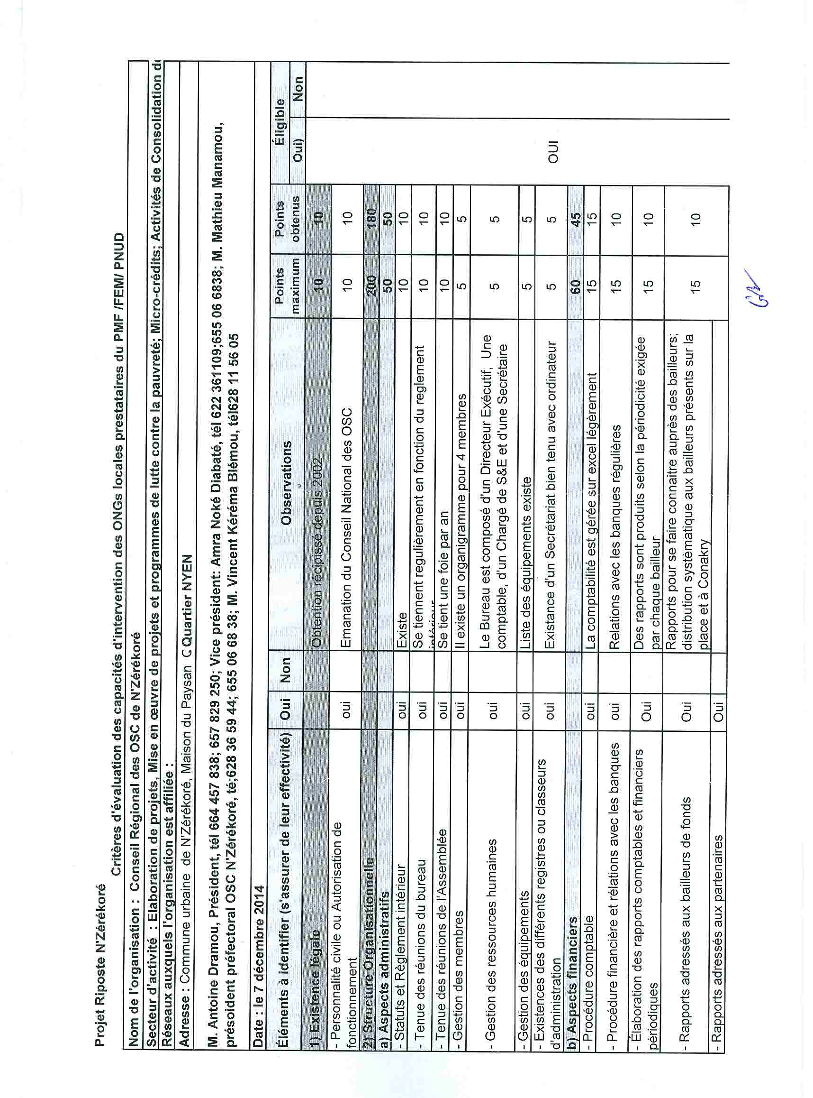
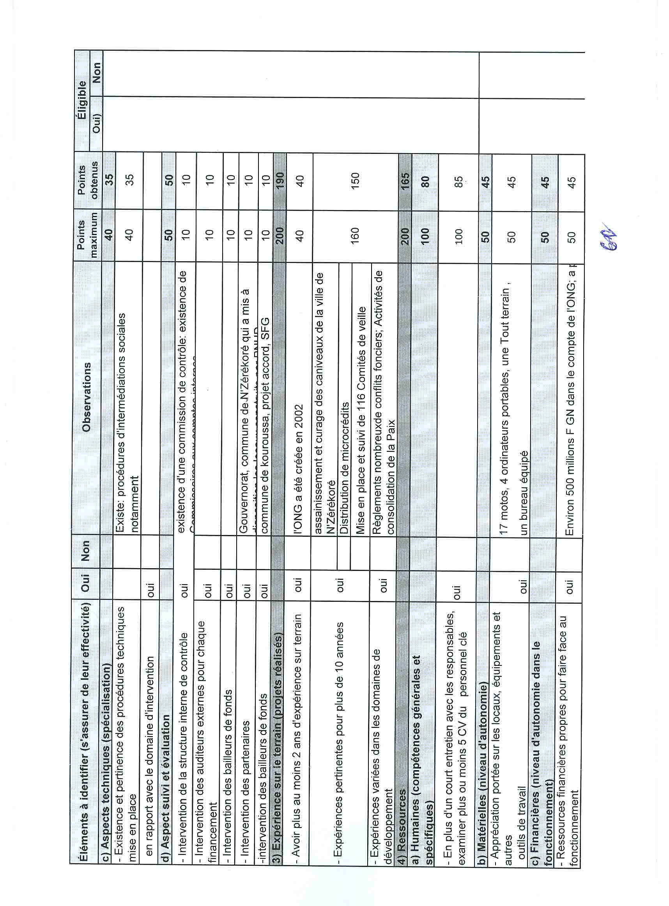

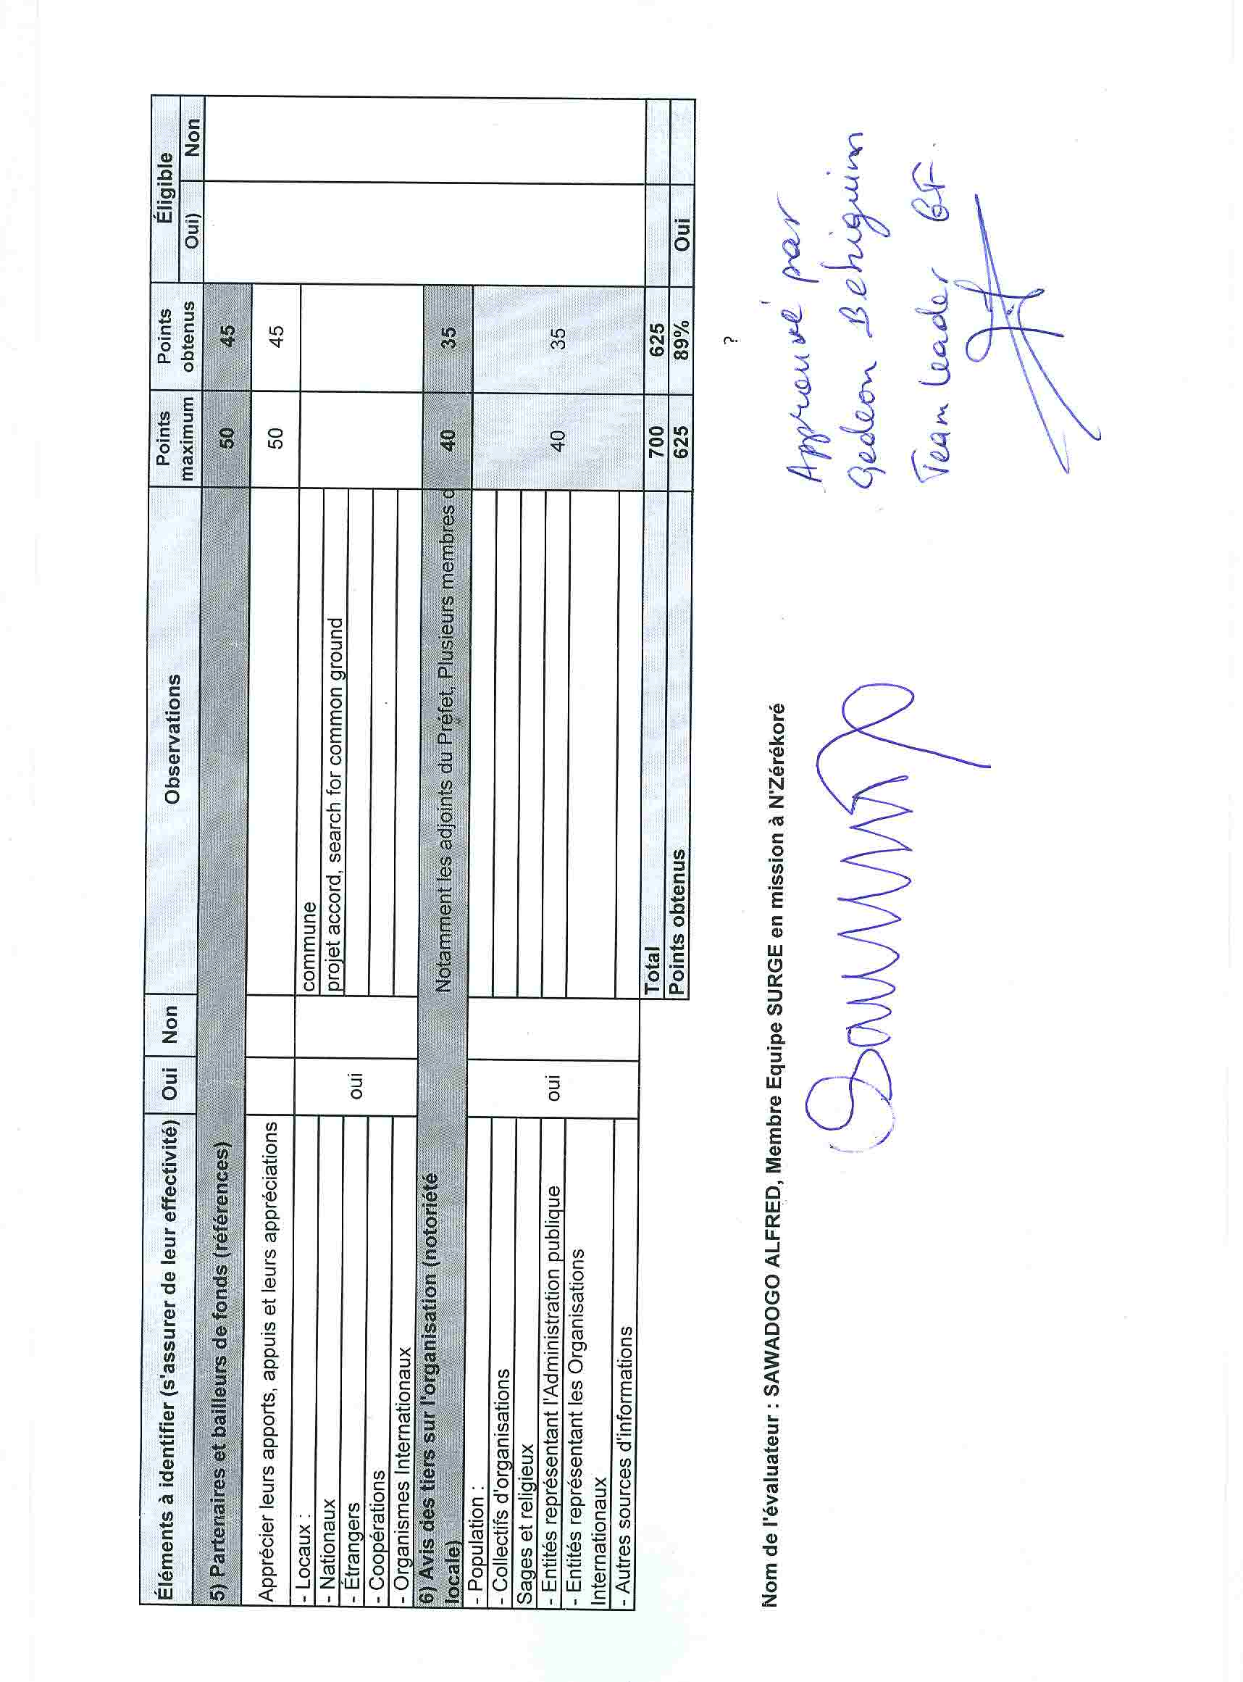

Thomas, C. USAID. ‘At the Heart of Ebola - Health Systems That Need Strengthening’. 6 October 2014. http://blog.usaid.gov/2014/10/at-the-heart-of-ebola-health-systems-that-need-strengthening/
Duff, M. & DiLorenzo, S. Associated Press. ‘Ebola takes big toll on already poor health care’. 30 August 2014. http://news.yahoo.com/ebola-takes-big-toll-already-poor-health-care-151913199.html
Salaam-Blyther, T. Congressional Research Service. ‘The 2014 Ebola Outbreak: International and U.S. Responses’. 26 August 2014.
(Centre d’Etudes et de Recherche pour le Développement/Centre Africain pour la Formation et le Développment/Coordination Nationale des Organisations de la Société Civile)
For GEF projects, the agreement with any NGO pre-selected to be the main contractor should include the rationale for having pre-selected that NGO.

